**GPM Application**

**Today Session Preview – 22-1-2025**

1. Topic
2. Audience
3. Functionality
4. Navigating the Interface
5. Error handling and trouble shooting.
6. Database SQL Tables and bugs.
7. **Topic – “Rule composer”**

Meeting recording (1hour 8 minutes) and URL:  
<https://teams.microsoft.com/l/meetup-join/19%3ameeting_OWRiYjE0YjAtOGM4Zi00YmI4LTg3YTQtNjQ2YTM1NjdkMTgy%40thread.v2/0?context=%7b%22Tid%22%3a%221e355c04-e0a4-42ed-8e2d-7351591f0ef1%22%2c%22Oid%22%3a%223b42d949-b7c8-4a05-bec8-092715644022%22%7d>

1. **Audience: Sagar (Host) from Hcl team,**   
   Divya (Kantar), Ashok (Cognizant)and cognizant support team.
2. **Functionality:**

1. Rule composer is used to run the SQL query and schedule the jobs and get the data by executing the queries by users as they do not have access to database, it will be useful for data security and privacy, data integrity, controlled access.

2. The main use of the Rule Composer is users can schedule the activities to retrieve the data in sql database server. In GPM the users can create the job through GPM admin site to execute the particular script in given schedule time.

3. Rule Composer is configured in Admin Screen. Super User will schedule a job to execute a query in SQL database server in scheduled time.

4. Each country has their own Rule Application Created. “Rule Application” is taken care by Dev Team. Rule application, versions, entry list, rules, schedules are pulled from IR author. Users cannot create them.

5. User can only write the query to execute and get the update and check the history and status of the scheduled job.

6. The Rule applications are created in irAuthor, ir Author is the authoring tool provided by In Rule Technology for creating and managing business rules. It offers a user-friendly interface that allows users to define, test, and deploy business rules without extensive cog. This tool is particularly useful for organizations looking to implement decision automation and ensure consistency in rule application across various systems.

7. Visual Cron is an automation, integration, and task scheduling tool for Windows, enabling users to streamline various processes without programming skills.

8. Visual Cron can schedule and execute scripts or command-line operations that interact with IR author’s rule deployment processes. Additionally, Visual Cron’s API allows for programmatic control, which could be utilized to manage tasks associated with IR author.

9. Jobs is scheduled in “Visual Cron”, based on this the schedule will run in database.

10. Visual Cron maintenance is taken care by Satish and Gopi. Direct any issue related to job runs.

1. **Navigating the Interface of “Rule composer”:**

1. Login to GPM Admin screen, select the country.  
  
 url: Iberiaadmin-qcgps.kantarworldpanel/#/admin-screens

2. Go to menu-> Rule composer.

Please check the below screen shot for your Information.

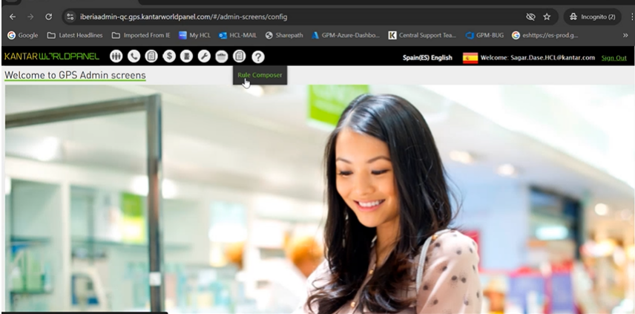

3. When we open the rule composer The application will display all the created jobs in the system.

**Action:** Helps to execute a query/job

**Stop job:** Indicates the stopping of job.

**Edit:** Super user can edit the existing query/job

**Status:** Display the status of a job whether its failure or successful.

4. To create new job:

Click on + icon and fill the required details

1. We can see the output of the query in Query output column. Please refer the below screen shot.

1. Job Audit :

From Job audit we can see the status of job, please look into the below screenshot.

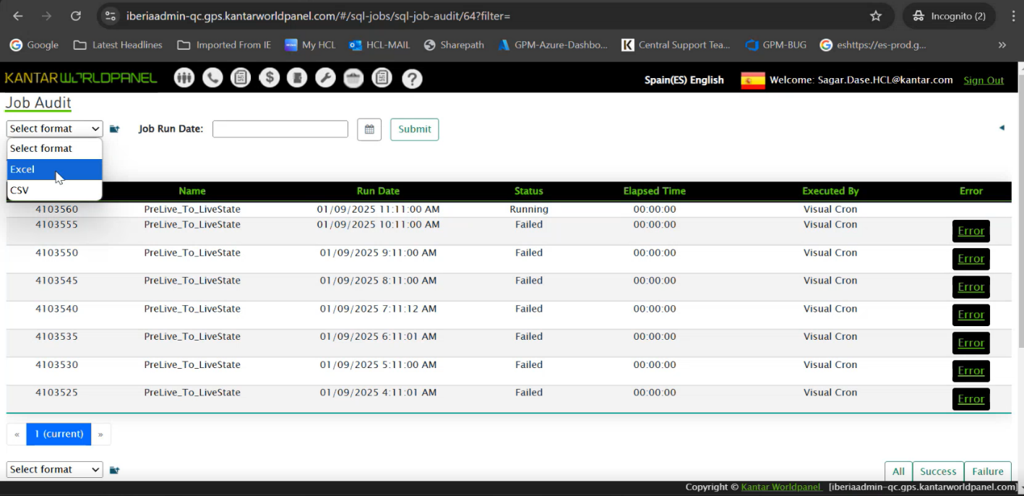

**5. Error handling and troubleshooting:**

1. To check the status of the job, go to Job audit, there will be details of the job which are running, failed or there is any error.

1. Click on the error, we will get the reasons and logs for the error
2. A screenshot of a computer

   Description automatically generatedScroll down and we see Job Actions Audit, here there will be hyperlink mentioned for the error and in the hyperlink, there will be logs of the error and user can troubleshoot the error based on the logs. Please refer the below screen shot.
3. **Example of the error:**
4. If the query is running for longer time, the server kills the execution and throw an error.
5. In this case, we can run the query after some time and check if the same error exists, in that case need to reach out to Dev team for further troubleshooting.
6. If other jobs are running at a same time in the same server for same rule application, there can be error, need to reach out to Dev team for further troubleshooting.
7. **Database SQL Tables and bugs.**

1. Login to GPM Admin screen, select the country.

There are 4 tables present in the database.

1.Sqljob

2.Sql JobAudit

3.Sql JobRuleActionAudit

4.BusinessRuleExceptionLog

Few queries to fetch the data from the database:

To check the job for job id 64: select * from sqljob where id = '64'

To check the top 10 job status which are recently executed: select top 10 * from SqlJobAudit where Jobid = '64' order by CreationTimeStamp desc

To check the rule action associated with job id 4127673: select * from SqlJobRuleActionAudit where JobAuditId = 4127673

To check business rule for job audit 4127673: select * from  BusinessRuleExceptionLog where JobAuditId = 4127673